**Exp No: 2**

**Date:**

**IMPLEMENT A LEXICAL ANALYZER TO COUNT THE NUMBER OF WORDS USING LEX TOOL**

**AIM:**

To implement the program to count the number of words in a string using LEX tool.

**STUDY:**

Lex is a tool in lexical analysis phase to recognize tokens using regular expression. Lex tool itself is a lex compiler.

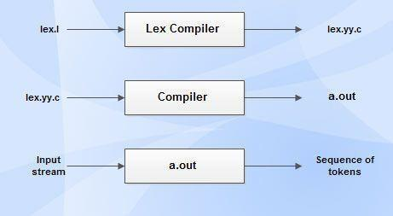

* lex.l is an a input file written in a language which describes the generation of lexical analyzer. The lex compiler transforms lex.l to a C program known as lex.yy.c.
* lex.yy.c is compiled by the C compiler to a file called a.out.
* The output of C compiler is the working lexical analyzer which takes stream of input characters and produces a stream of tokens.
* yylval is a global variable which is shared by lexical analyzer and parser to return the name and an attribute value of token.
* The attribute value can be numeric code, pointer to symbol table or nothing.
* Another tool for lexical analyzer generation is Flex.

**STRUCTURE OF LEX PROGRAMS:**

Lex program will be in following form declarations

%%

translation rules

%%

auxiliary functions

**ALGORITHM:**

1. Initialize counters for line count (lc), space count (sc), tab count (tc), character count (ch), and word count (wc).
2. Define rules to match newline, space, tab, and non-space/tab/newline characters. Increment corresponding counters based on matches.
3. Prompt the user to enter a sentence.
4. Invoke lexical analysis using yylex().
5. Signal the end of input.
6. Display the total word count.

**PROGRAM:**

%{

#include<stdio.h>

int lc=0,sc=0,tc=0,ch=0,wc=0;

%}

%%

[\n] { lc++; ch+=yyleng;}

[ \t] { sc++; ch+=yyleng;}

[^\t] { tc++; ch+=yyleng;}

[^\t\n ]+ { wc++; ch+=yyleng;}

%%

int yywrap(){ return 1; }

int main(){

printf("Enter the Sentence : ");

yylex();

printf("Number of words: %d\n",wc);

return 0;

}

**OUTPUT:**

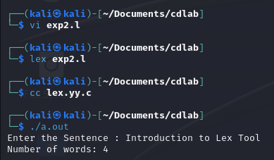

**RESULT:**

Thus, the program to count the number of words in a string using LEX tool has been implemented.